TC_007_001

Skipped

TC_007_002

Skipped

TC_007_003

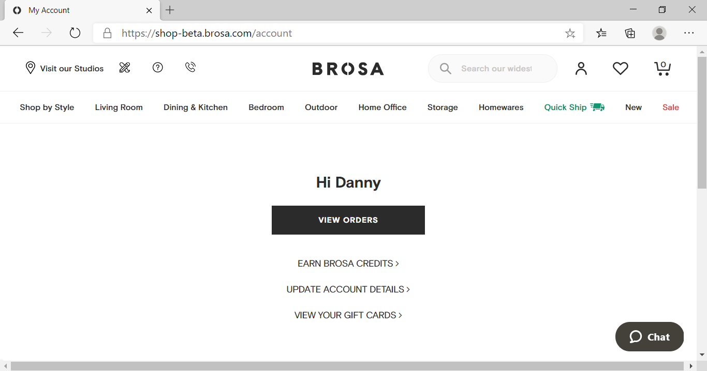

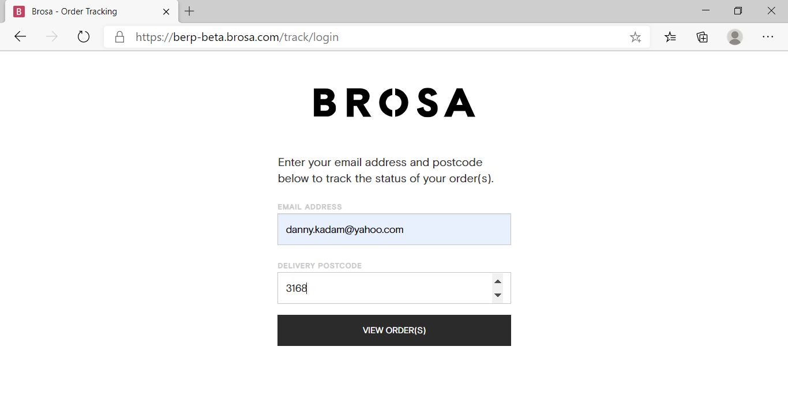

TC_007_004

